For the rules of playing the chess game please refer to the rules established by the US Chess Federation. They can be found on their website or if you click on the following link: http://www.uschess.org/content/view/7324

Table of Contents
- How to move a piece
- How to castle
- How to perform Pawn Promotion
- Additional Features

How to move a piece:

- Click on the piece you would like to move
  - If the square clicked is an illegal move, the respective message will popup
- If legal moves exist for the piece clicked, all of the possible moves would be highlighted in green like the picture below
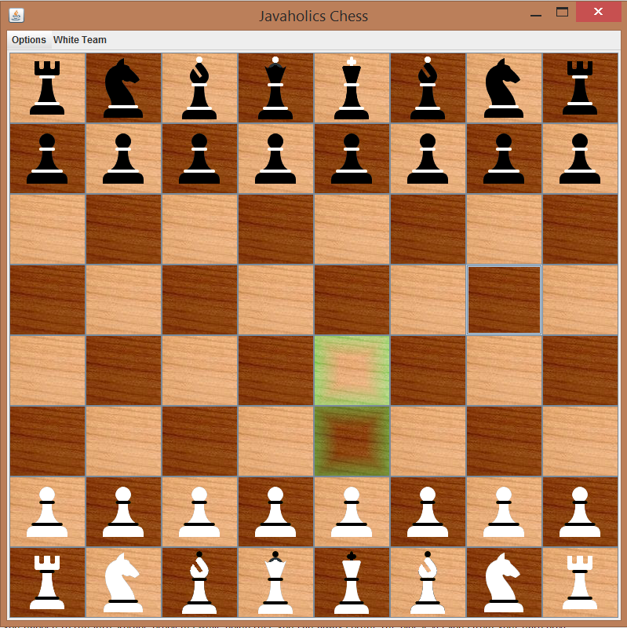
- Click on the highlighted squares to finish the move (The image show below is after the second highlighted square from the bottom was clicked)
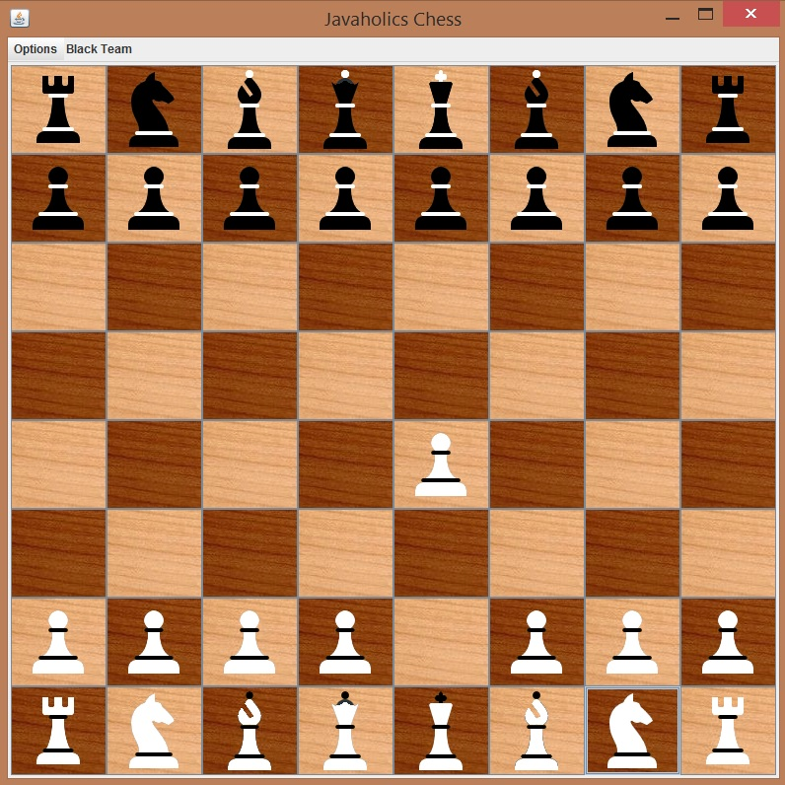

How to Castle

- Make sure that castling is a legal move.
- Click on the respective king and a spot two columns next would be highlighted (The spot is shown in red below)
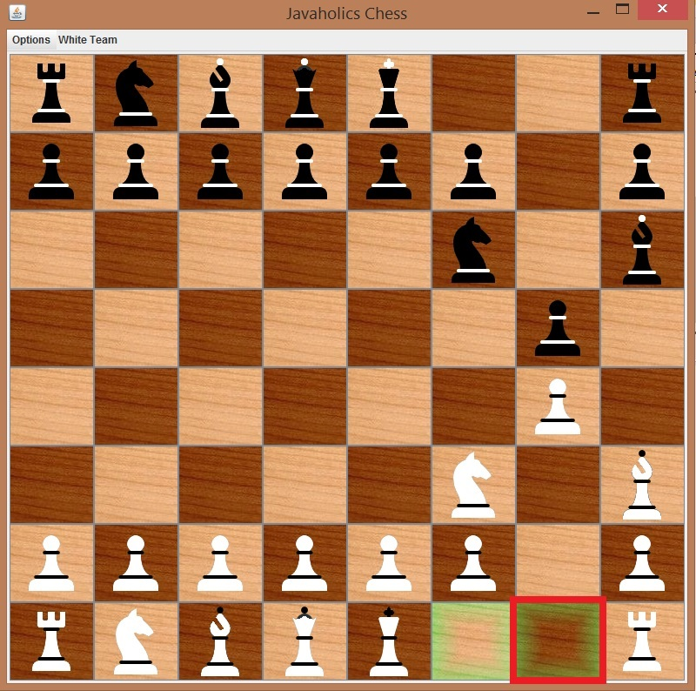
- Click on the respective spot and the king will castle (The image shown below is after the red spot in the image above got clicked).
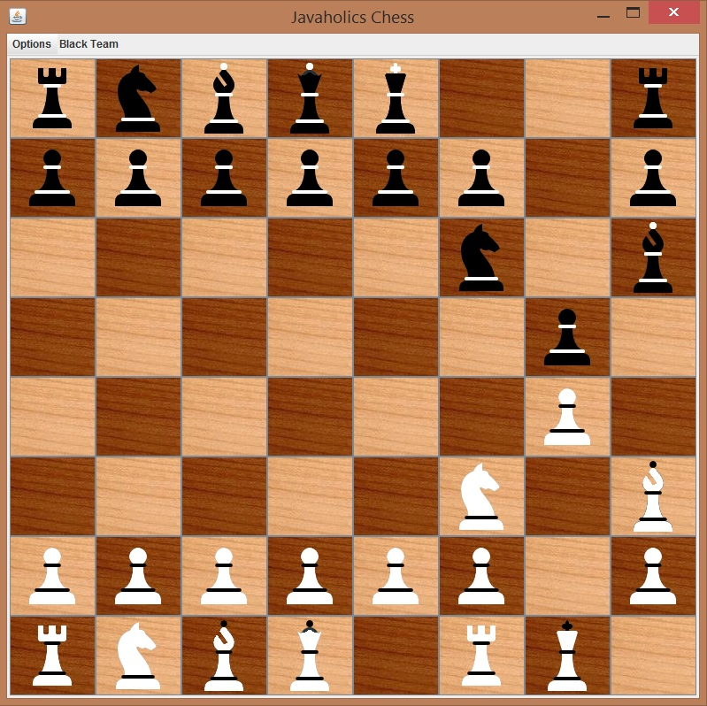

How to perform pawn promotion
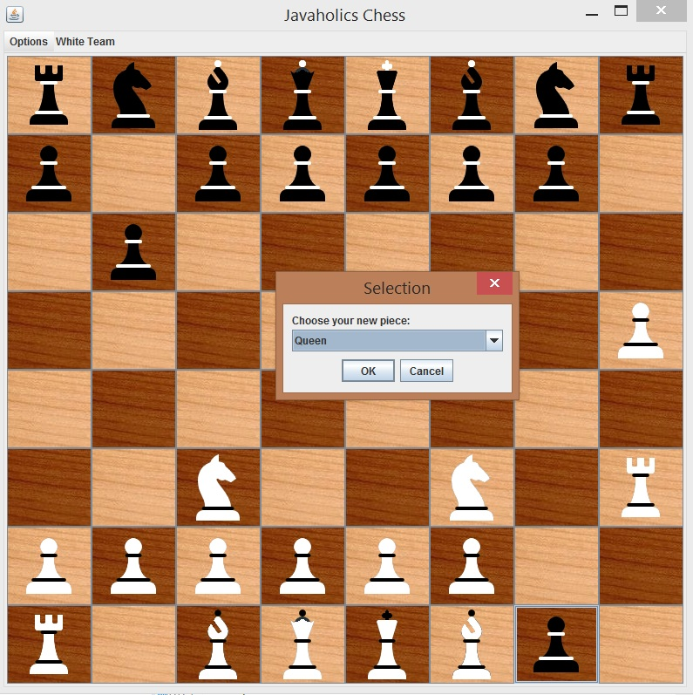
- Get the pawn to the other side of the board. Once the pawn reaches the end, a dialog box like the one show below popups upAfter you click ok, the respective piece shows up in the spot (the image below is what happens after ok was clicked on the image above.
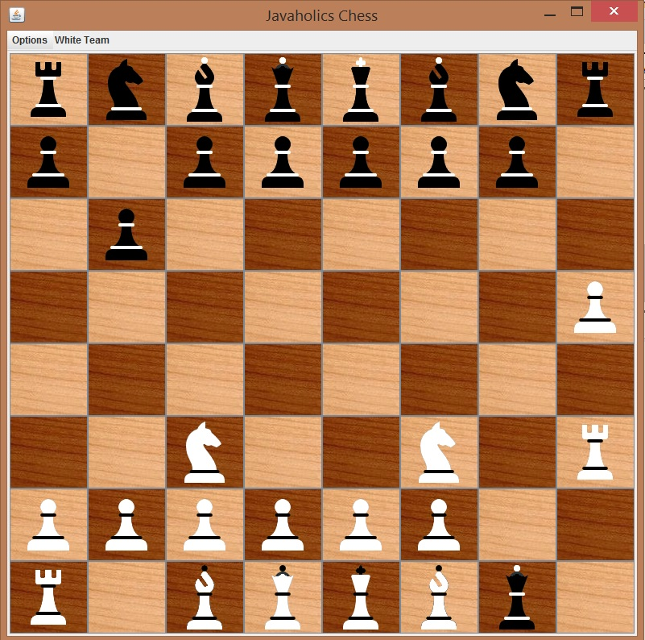
Extra Features
- All of the features shown below are in the red box. They are also labeled from 1 to 4 with the descriptions below the picture
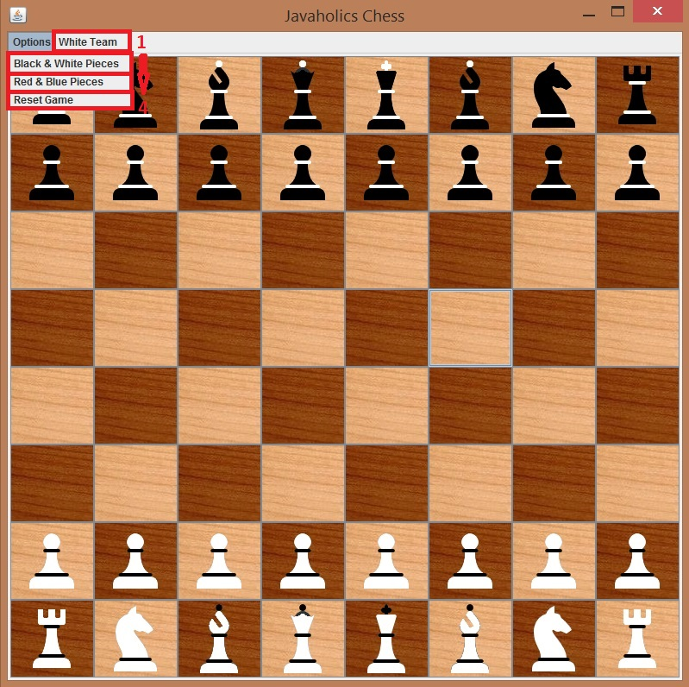
- Shows the respective teams turn
- Black & White Pieces: Click on this if you want to display the game pieces as black pieces and white pieces
- Red & Blue Pieces: Click on this if you want to display the game pieces as red pieces and blue pieces
- Reset Game: Click on this if you want to start a new game.

